Team 2

Trader Guidelines

Organocity

Trader

1. Traders need to sign up to put their products up for purchase from.

Traders can register from the same sign up as customer but select the checkbox in the form to send a request to the admin to get a promotion to the trader.

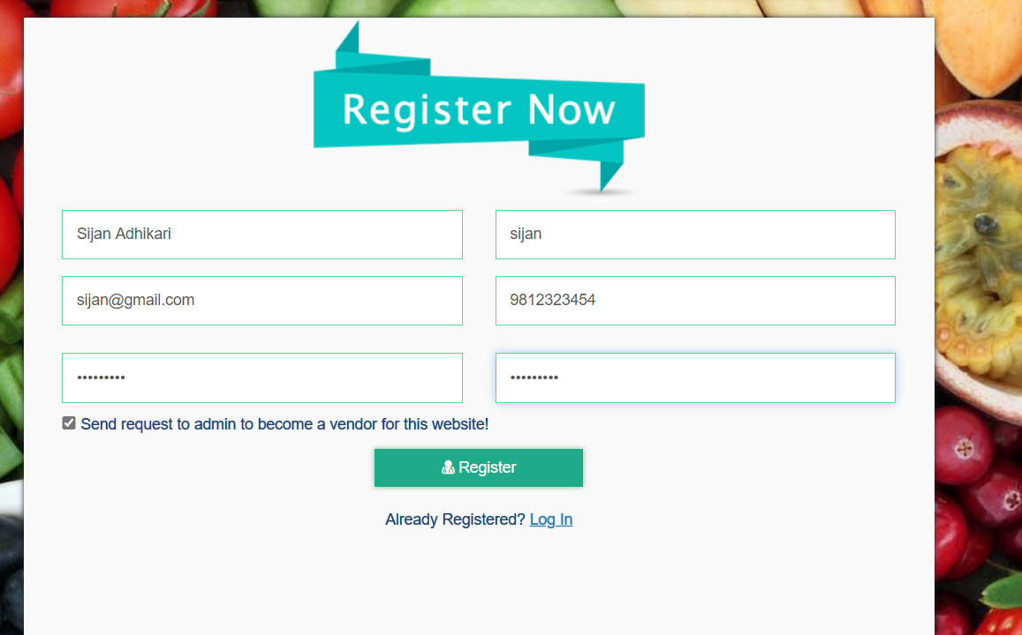

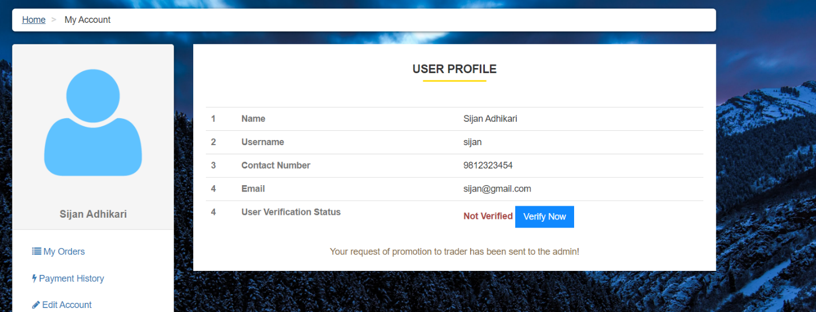

1. Once activated by the admin after verification traders can login by selecting the trader role to access their profile.

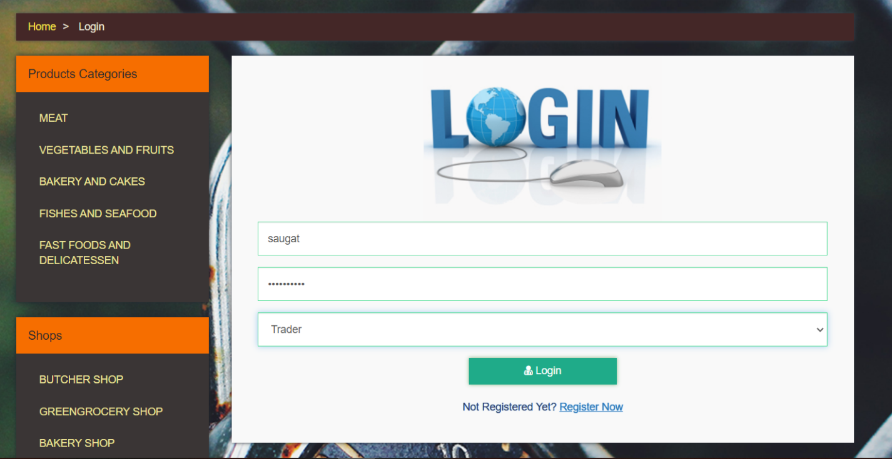

1. Once Logged In, trader gets an access to their respective dashboard.

This dashboard contains all sorts of quick data regarding their shops like

Total income, total shops, total products, if any product is out of stock and also the total contribution of the trader’s shop’s sales to the over sales of the organocity website.

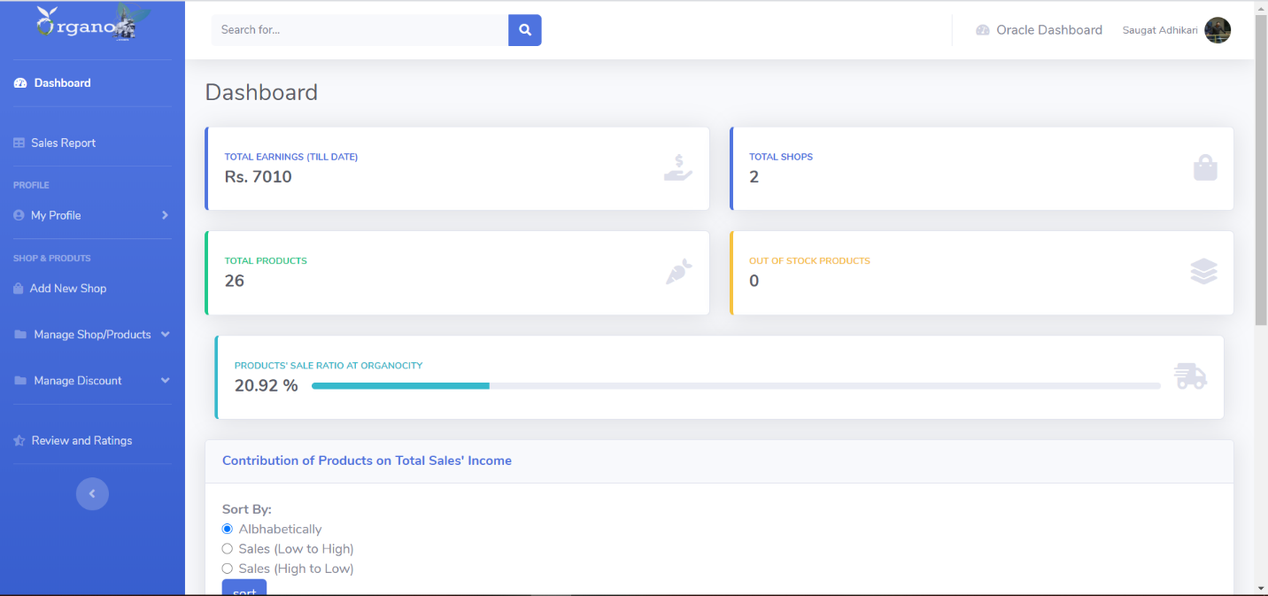

Furthermore, the dashboard also contains the data like total sales amount, quantities sold and the relative sales percentage of all the products associated with the trader’s shops. These data can also be viewed with some sorting added.

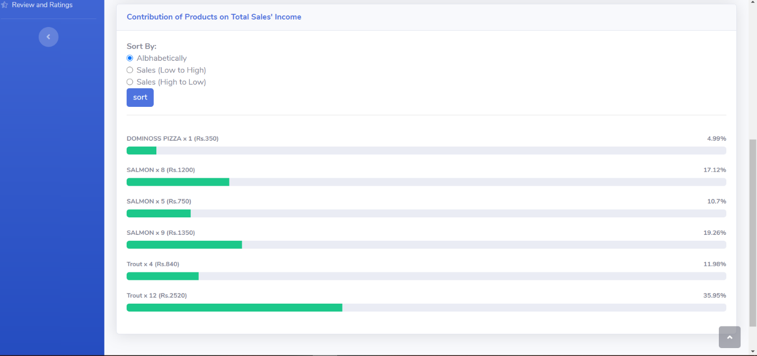

1. Traders can edit different details after logging into their profile.

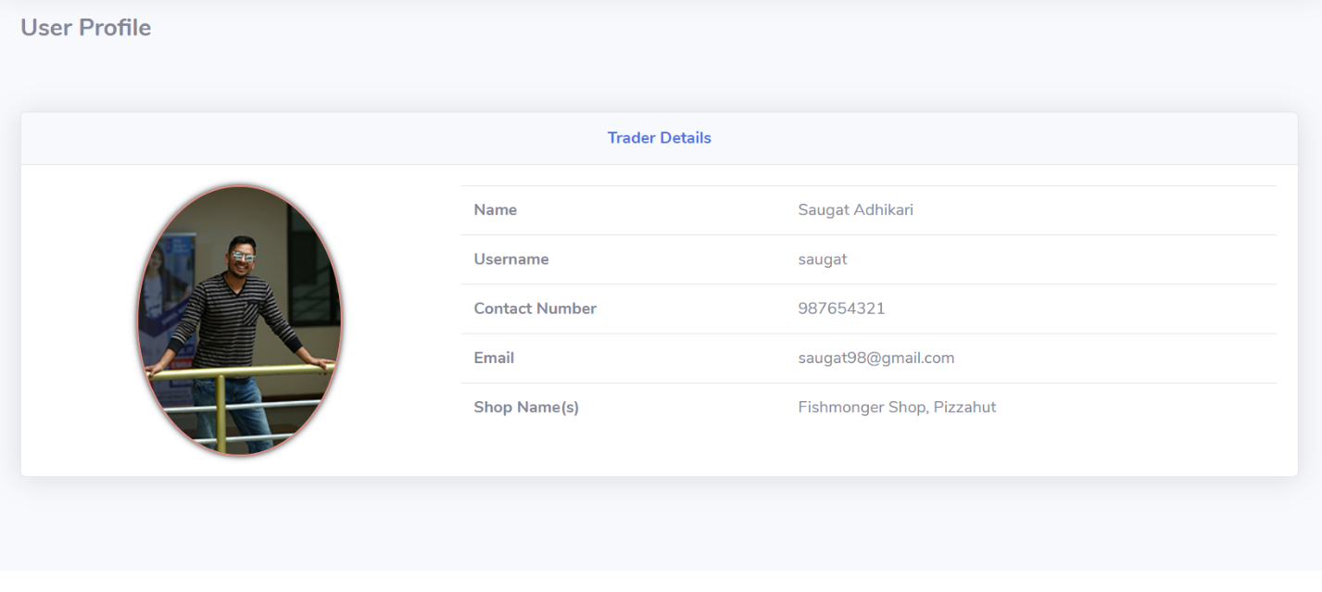

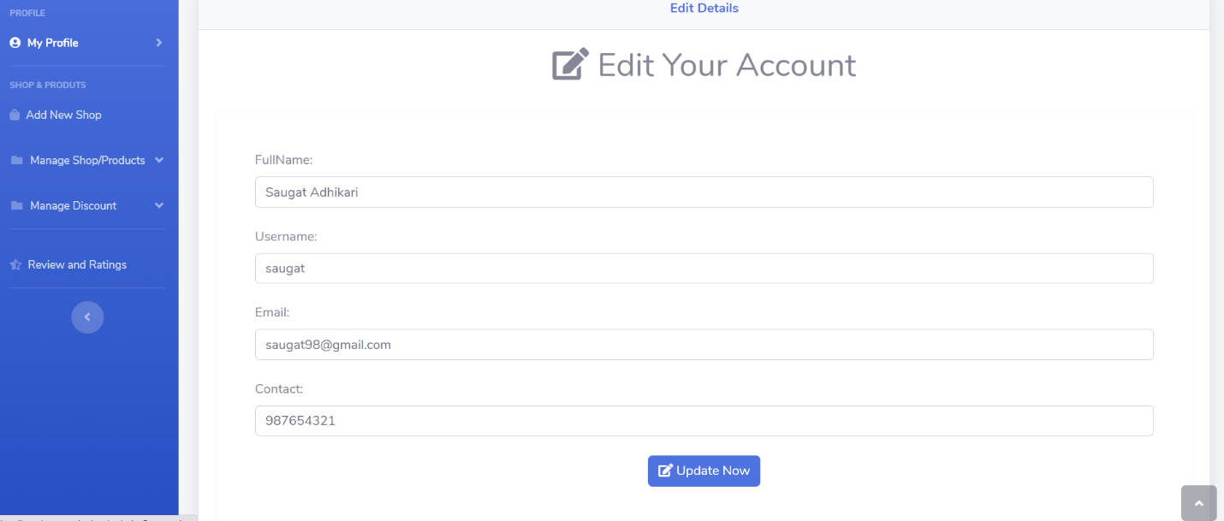

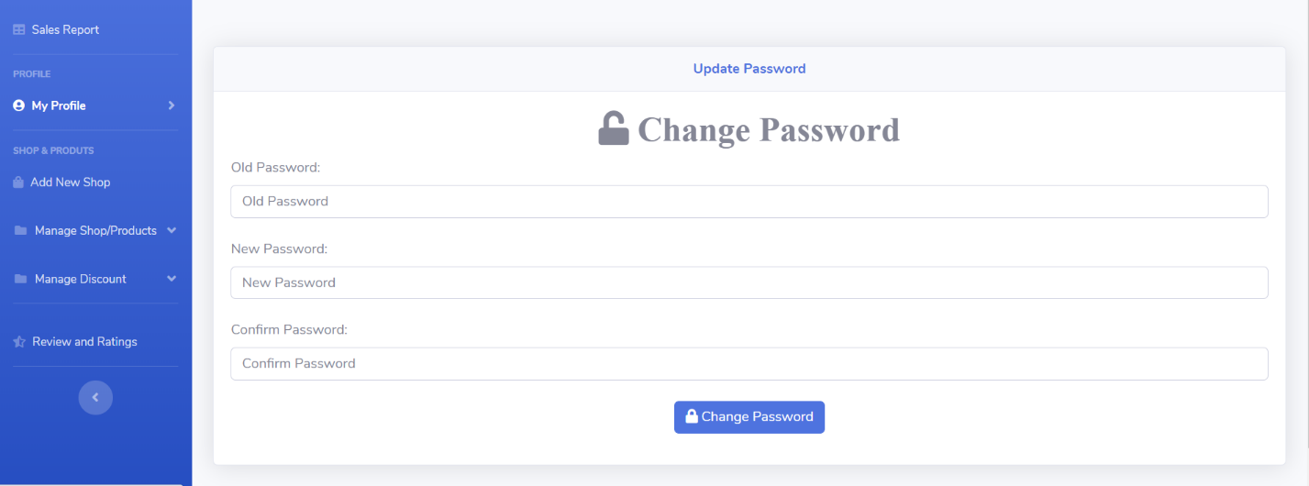

1. Traders can update their profile image as well as delete their account and all the data associated with their shops.

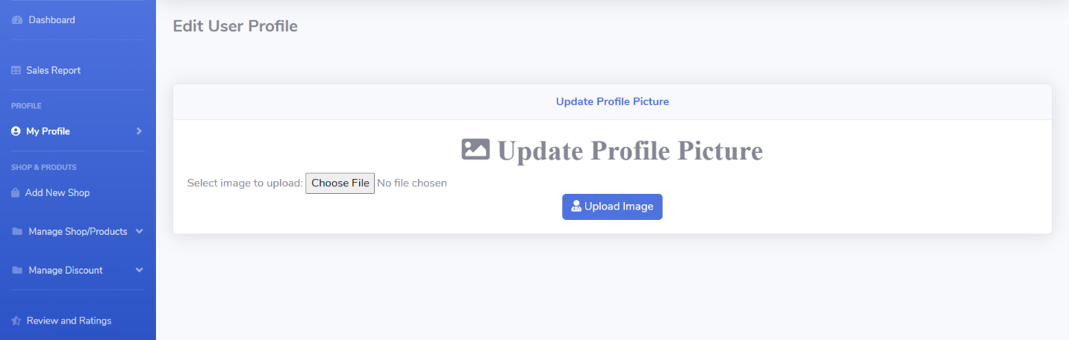

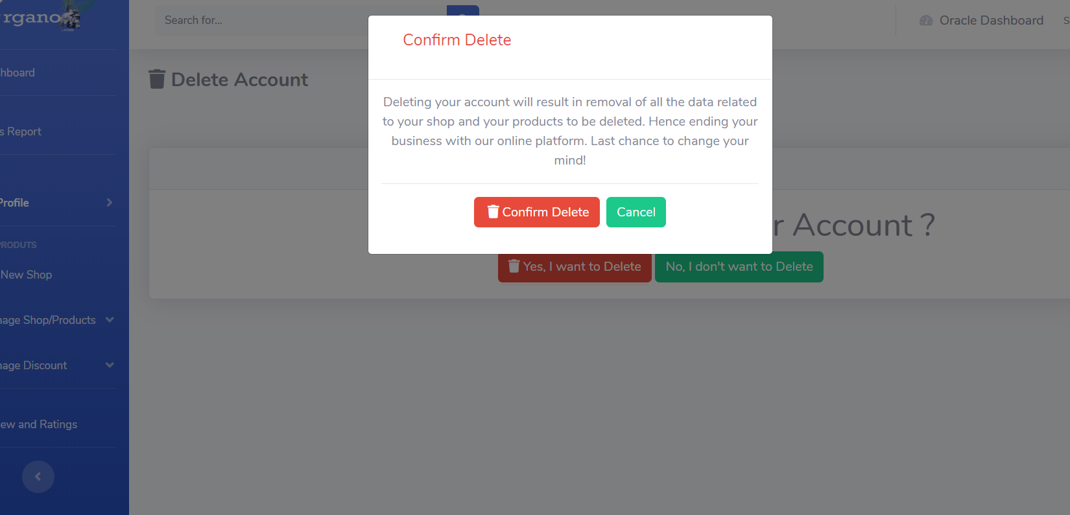

1. Trader can add new shop.

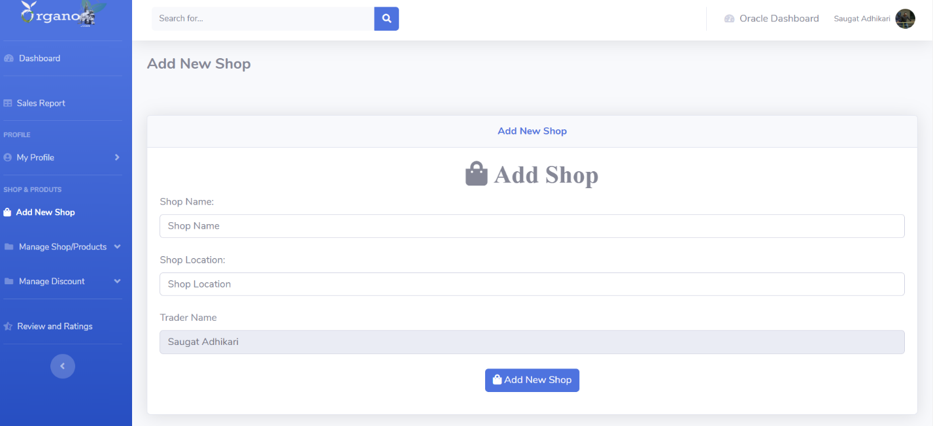

1. The products can be added to different shops separately.

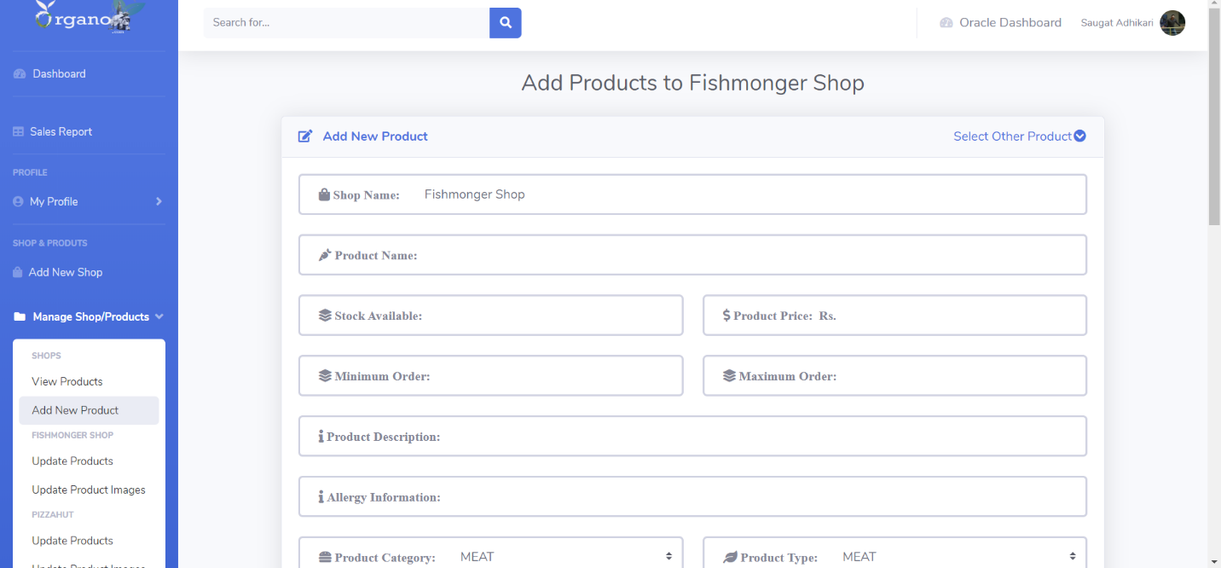

1. Traders can view products of different shops separately.

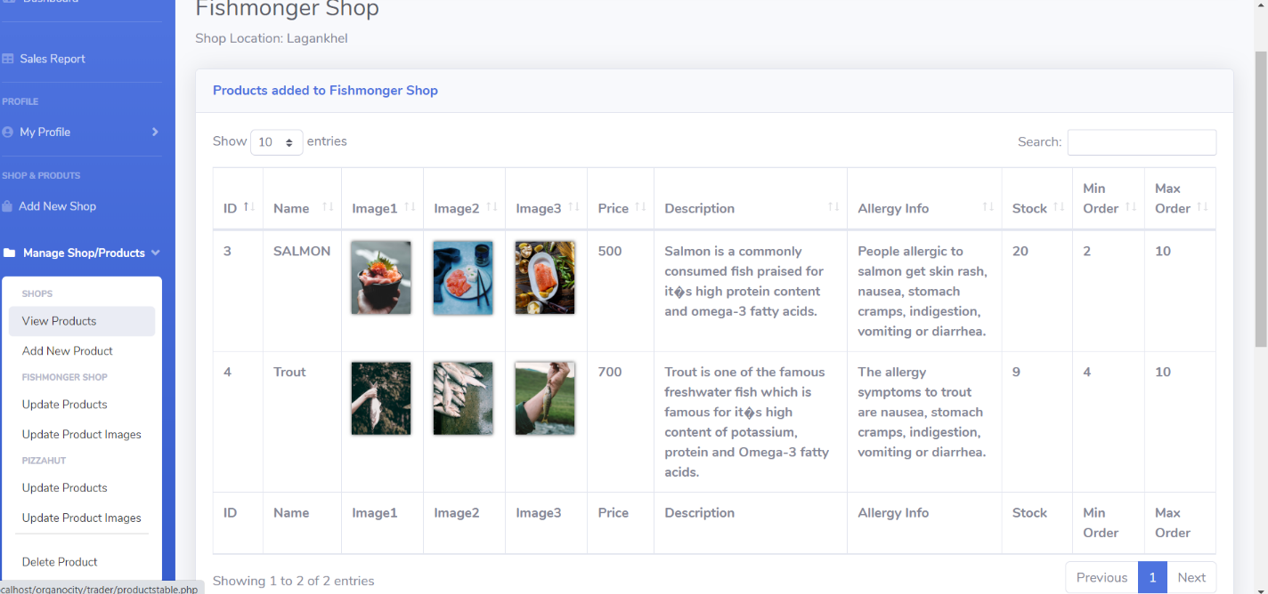

1. Traders can update, delete and change the pictures of the product of different shops.

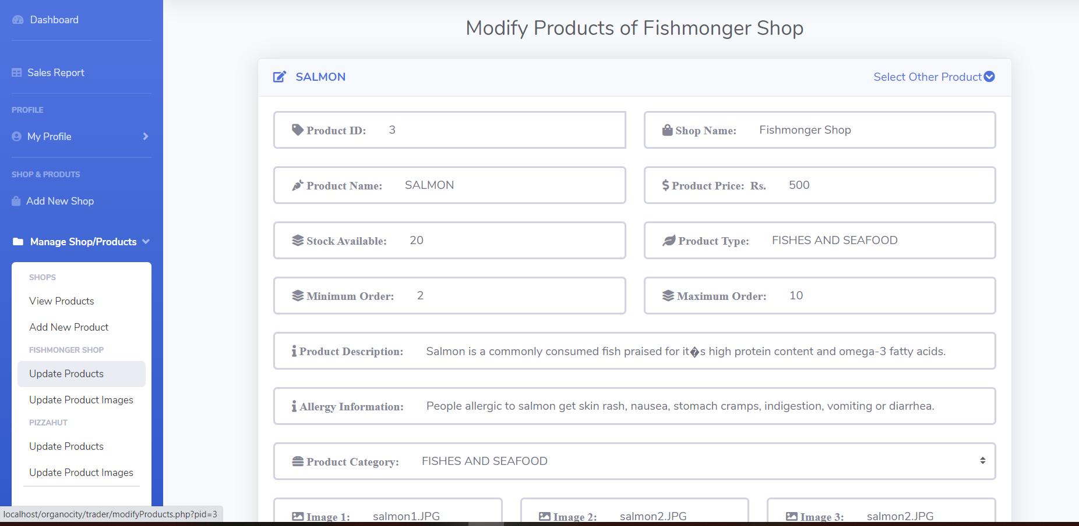

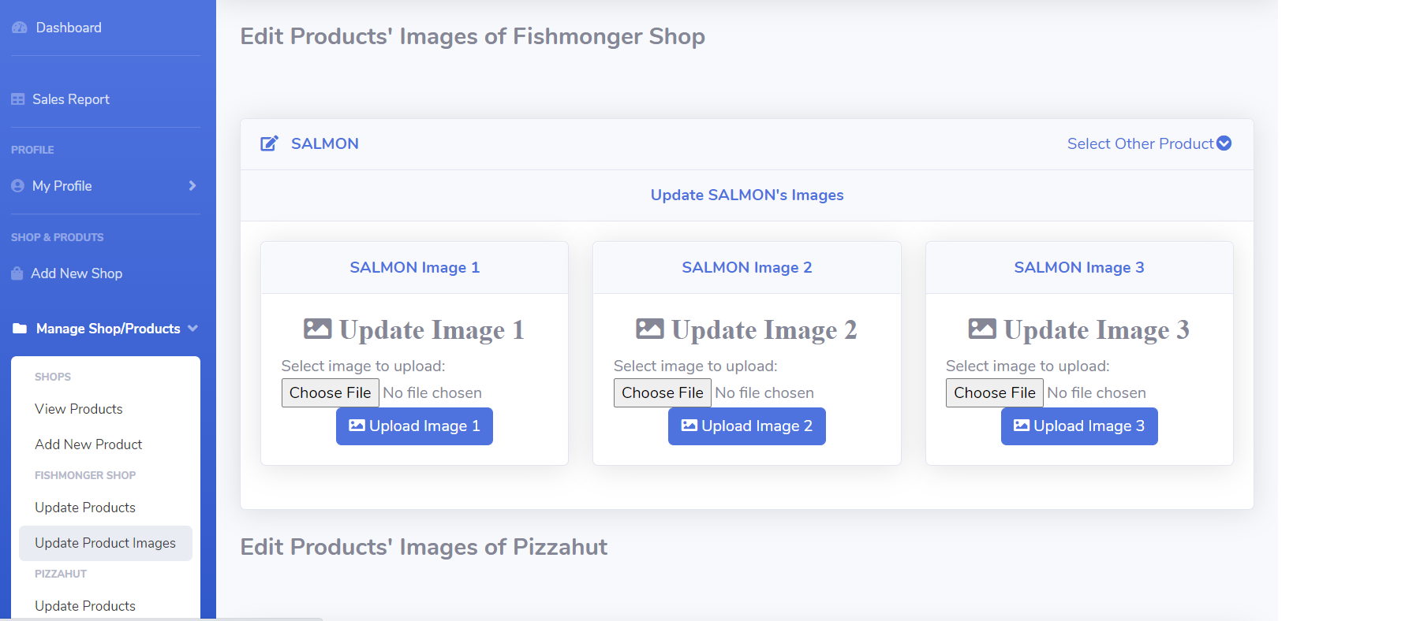

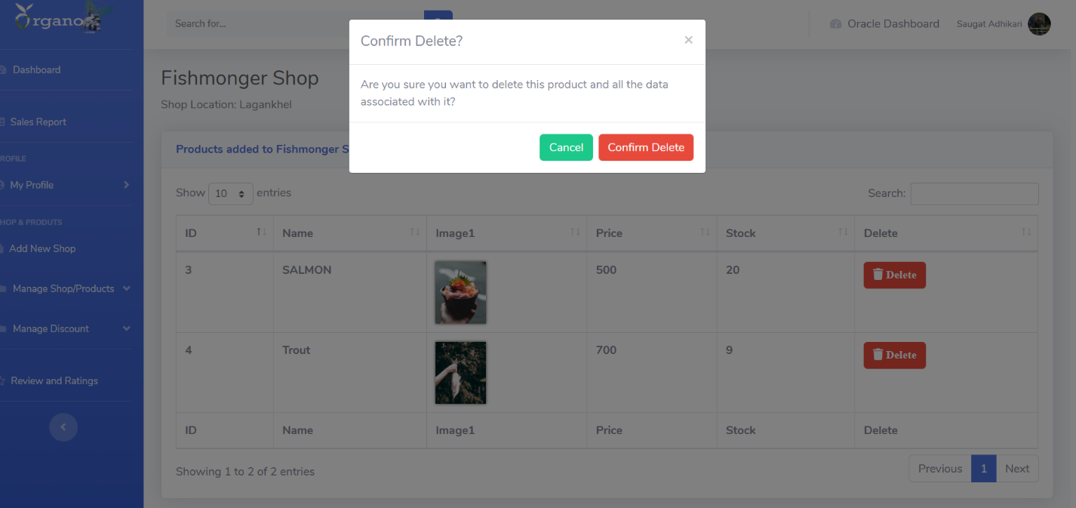

1. Traders can also add, modify and remove discounts to products of different shops.

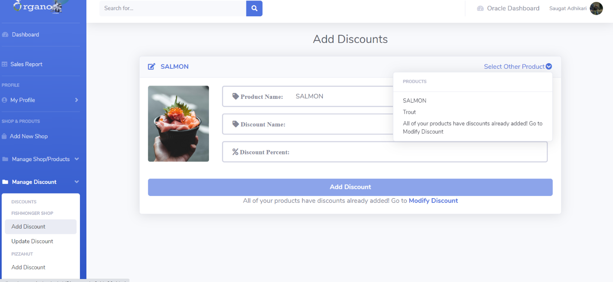

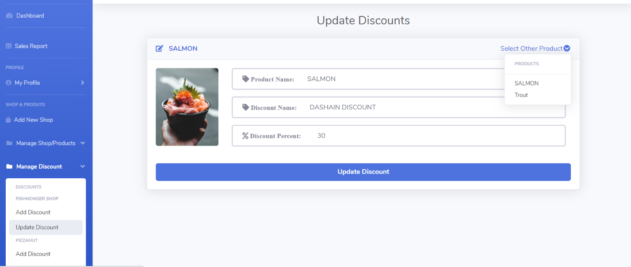

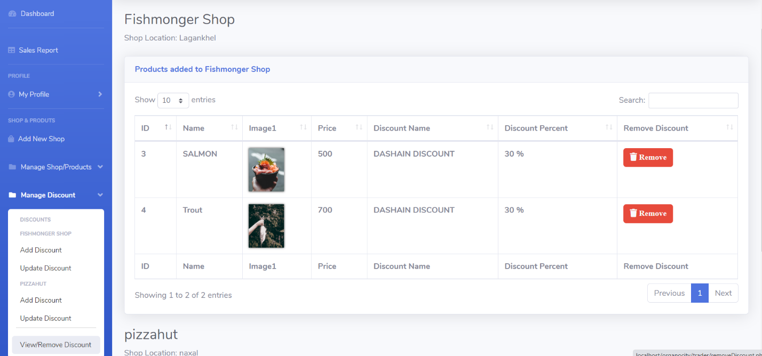

1. Traders can also see the reviews customers have left on products from their store.

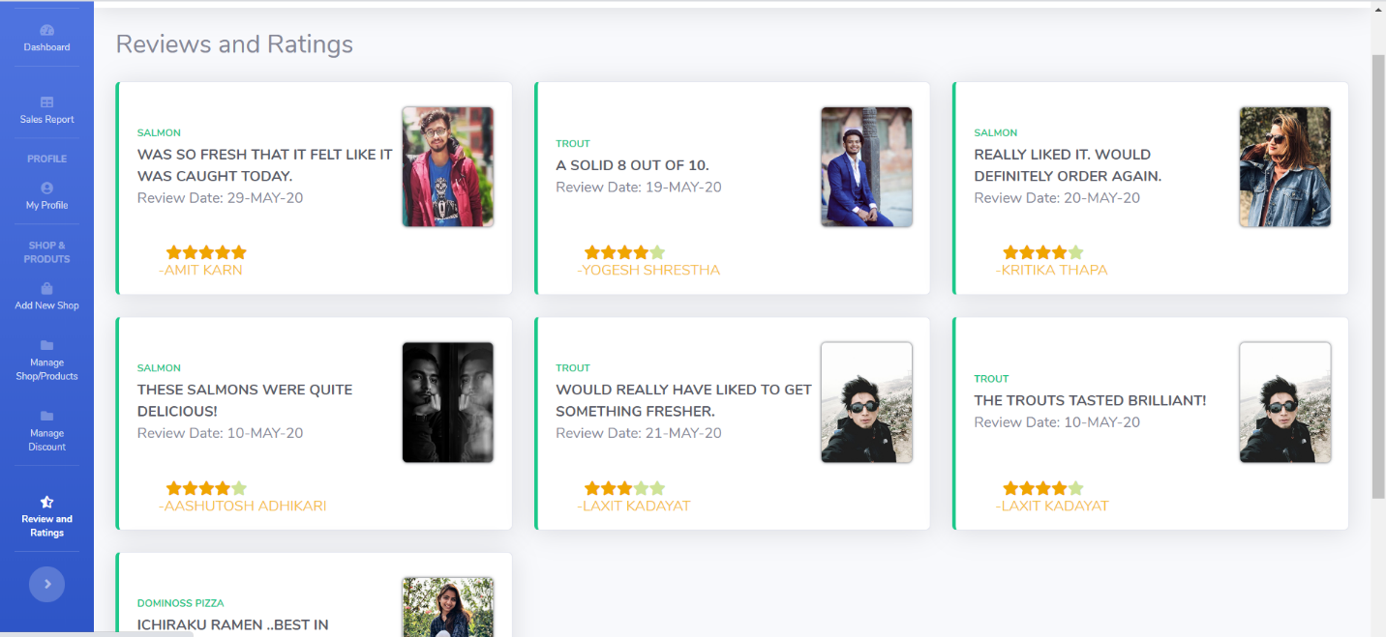

1. Traders can view the reports of sales of different products.

